STEPS TO REFRESH REPORTING SERVICE CONFIGURATIONS

- Go to following path:
C:\Program Files (x86)\Microsoft SQL Server\90\Tools\Binn\RSConfigTool.exe
- Open the Configuration Tool

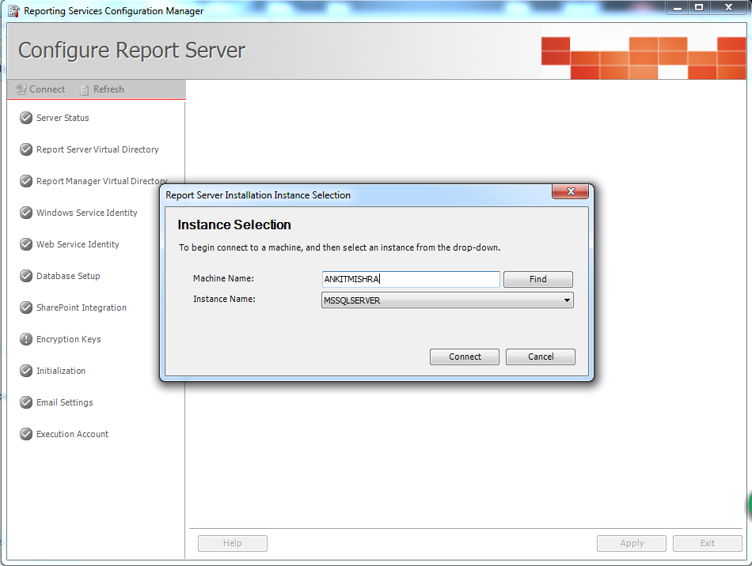

Click connect

- Click Refresh Button as shown below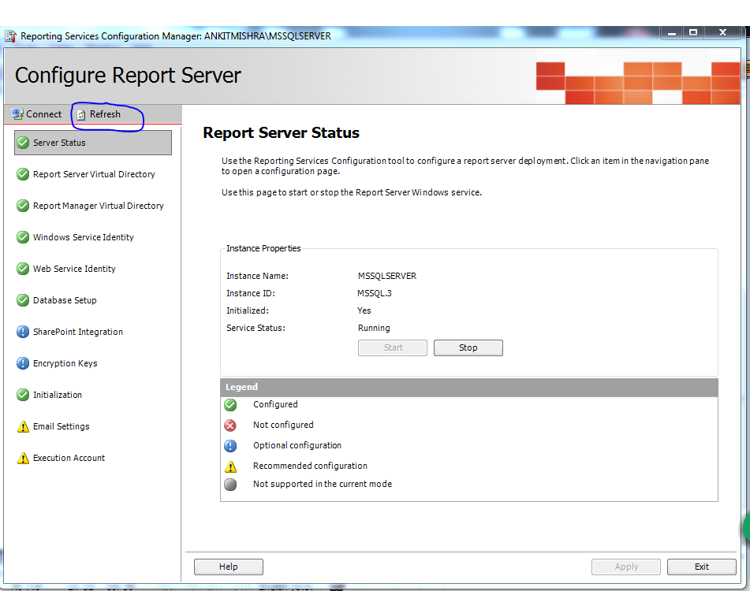

4- Reset IIS by opening start and typing “IISRESET” as shown below
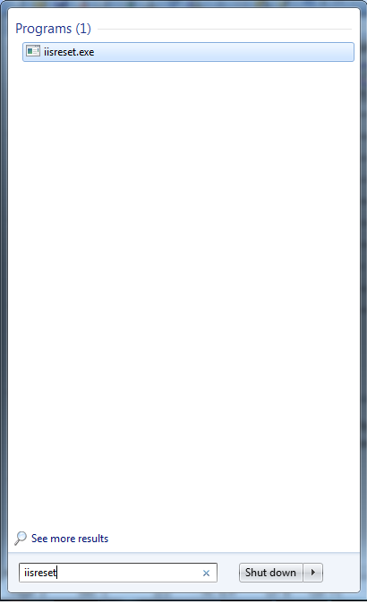

5- You are good to go your changes in configurations will reflect now.

